**Ford GoBike! Is it working?**

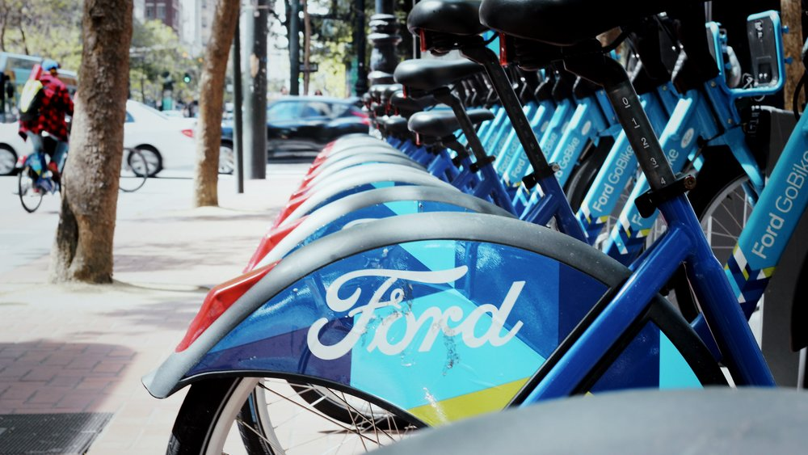

During my work on the Data Analyst Nanodegree program with Udacity, I came across an interesting data set for the GoBike bike-sharing system (now called Baywheels) covering the greater San Francisco Bay area. This is a network of rentable bicycles available at 262 stations throughout the bay area to rent with a credit card.

I was wondering whether the idea was actually working and if people did depend on bikes in their daily life, so I decided to collect the data of the first 3 months of 2020. The dataset was downloaded from https://s3.amazonaws.com/baywheels-data/index.html and multiple data files needed to be joined together to get a single dataset that required some data wrangling to prepare it for analysis (You can find the link to my original work in this [Github repo](https://github.com/michael-fawzy/DAND5-Communicate-Data-Findings)).

In this post I will discuss the answers to the following questions:

1. When most trips are taken in terms of "day of the week".
2. How long the average trip takes.
3. Whether the trip duration depends on the user type or not.
4. Comparing trip duration through months to conclude whether the idea is succeeding or not.

So, let’s dive in...

1. **When were most trips taken in terms of “day of the week”?**

After analyzing the final data set, I came up to the conclusion that most trips were taken in Wednesday. In general more trips were taken in work days than on weekends, which assumes that people may be using bikes in their daily commute to/from work.

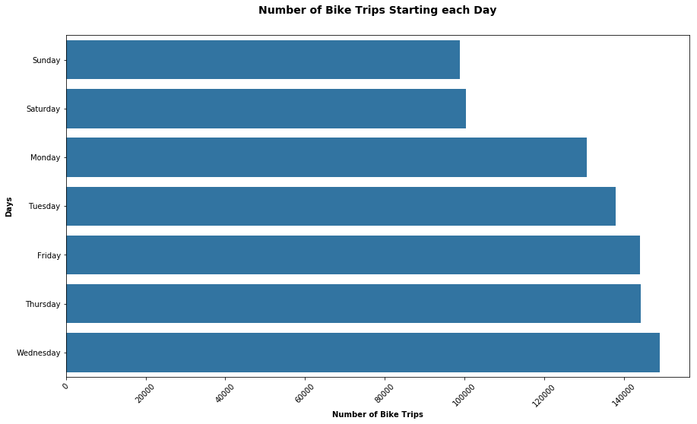

However, I couldn’t think of a reason why the highest number of trips was taken on Wednesday not on Monday. It seems that more people are still lazy in the beginning of the week to use bikes ☺

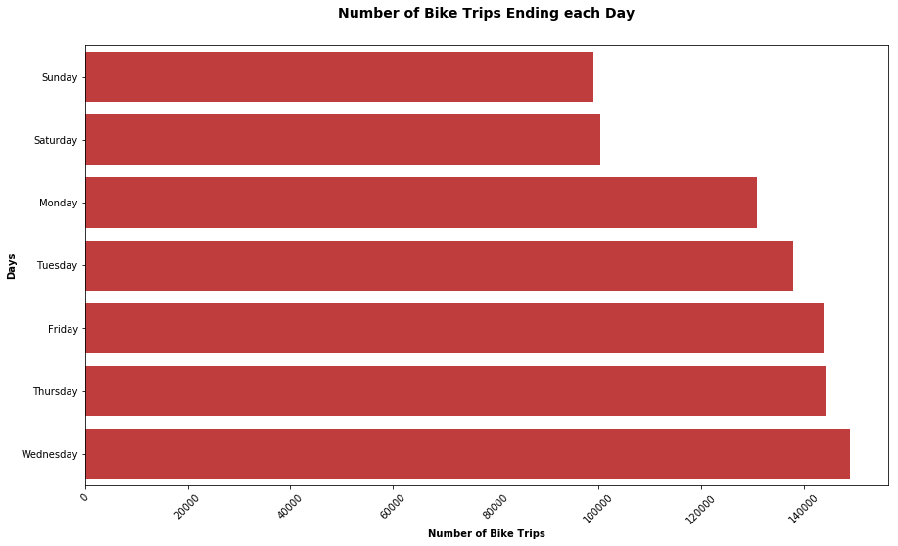

1. **How long does the average trip take?**

So, I thought, would the average trip duration support the previous conclusion?

I worked on the data to get my finding, and voila!

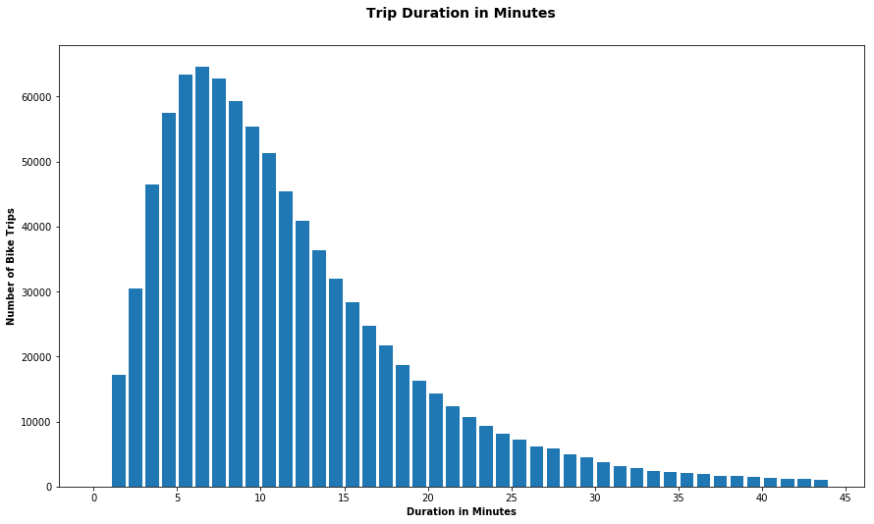

I found that the average trip duration ranged from 3-14 minutes which, in my opinion, looks like a typical daily commute duration.

So, I believe this result supports the previous findings.

1. **Did the trip duration depend on the user type or not?**

Bay Wheels has two types of clients; casual customers and subscribers (members).

Since most trip durations were less than 45 minutes, I decided I will first check whether there was a difference between both client groups at durations less than 60 minutes.

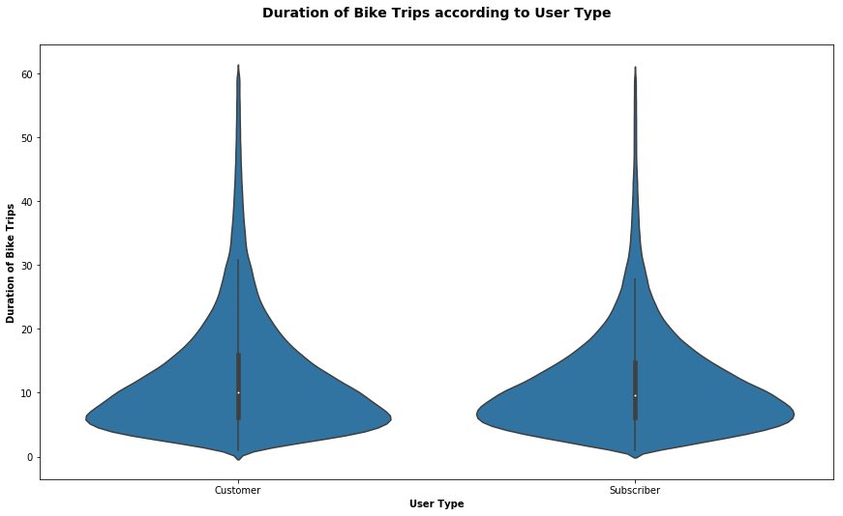

Well, we can clearly see that at durations less than or equal to 60 minutes, both customers (casual) and subscribers (members) have achieved similar durations of use.

However, when viewed by Month, without setting a duration limit, the plot showed that some customers had longer trip durations than subscribers. I guess those could be tourists or visitors to the area who wanted to enjoy the sights on a bike.

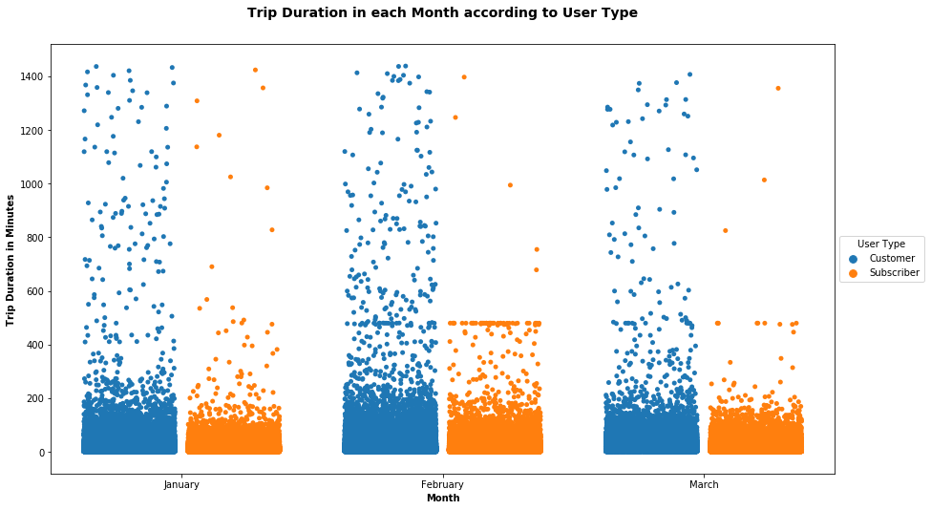

1. **Comparing trip duration through months to conclude whether the idea is succeeding or not?**

Now to the end result…

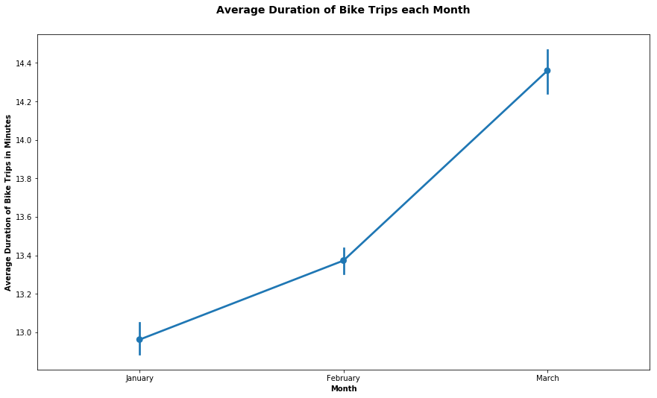

Average Trip duration has been increasing since Jan 2020 and reached its peak in March which concludes that people are depending more on bikes to go to farther places .

So, in the end, we can definitely say “YES!”

**The idea is actually working, and people are depending more and more on bikes every month. Awesome!**

https://michaelfawzy.medium.com/ford-gobike-is-it-working-5bafbea214b6